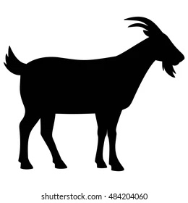
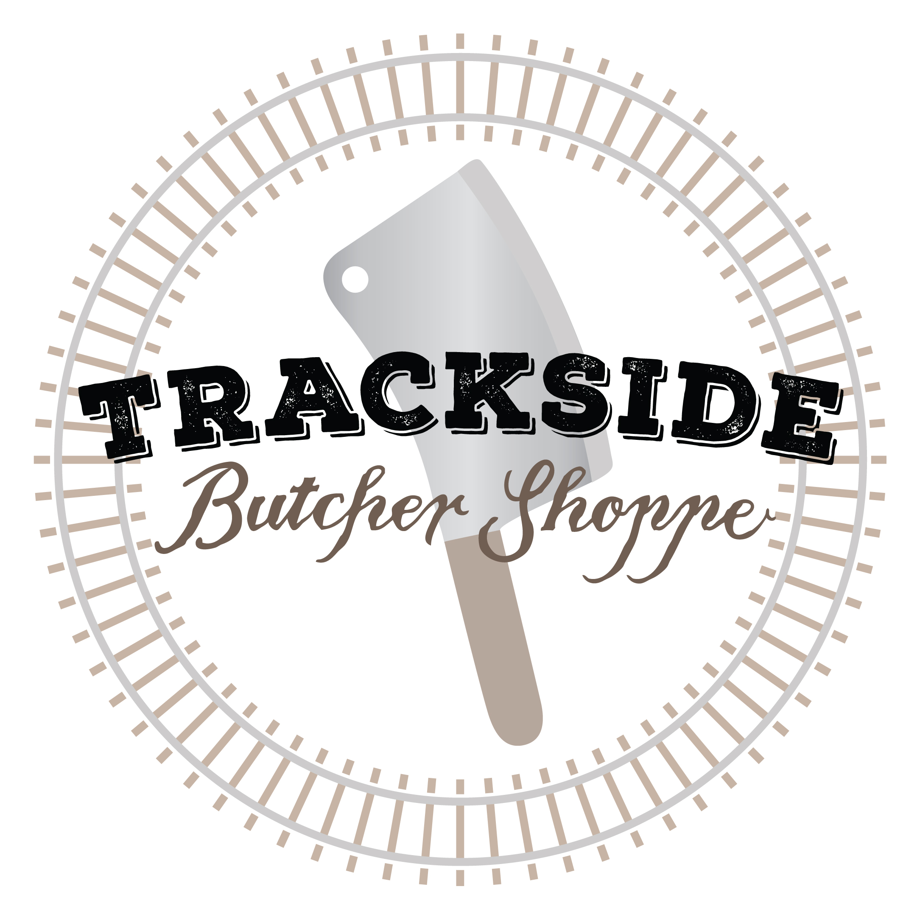
Producer _________________
No. of Animals ______
_____ of _____
Goat CUT SHEET

Date ___________

Name as appears on Label______________________________ Phone Number________________________

Tag Number ________ USDA ☐ ( $160 Flat Rate) CUSTOM ☐ ( $135 Flat Rate) WHOLE HALF
City,State________________________

Live Weight ________ Hang Weight ________

*Starred Items May Be Unavailable Depending On the Size Of The Animal, This Is To Insure The Safety Of Our Staff And The Quality Of Your Product
Extras
☐ Heart ☐ Liver ☐ Stew Meat*
SHANKS
☐ Whole ☐ Ground
NECK
☐ Roast ☐ Sliced ☐ Ground
DENVER RIB
☐ Whole ☐ Ground

LOIN
☐ Bone-In Chops ☐ Bone-In Roast ☐ Ground
SHOULDERS
☐ Bone-In Roast ☐ Boneless Roast* ☐ Bone-In Chops ☐ Ground

LEGS
☐ Bone-In Steaks ☐ Boneless Roast ☐ Bone-In Roast ( Leg of Lamb ) ☐ Boneless Roast with net

☐ Butterfly Roast without net ☐ Ground

CHOPS
Chop Thickness _______ INCHES Chops Per Package _______ Roast Size _______ LBS

RIB
☐ Whole Rack ☐ Half Rack ☐ Bone-in Chops ☐ French style rib chop* ☐ French style rib roast*

