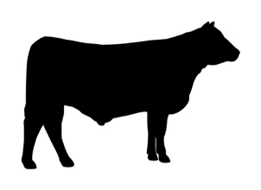
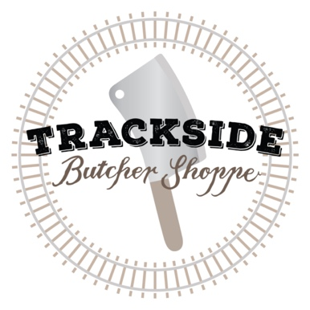
Producer _________________
No. of Animals ______
BEEF CUT SHEET _____ of _____

Date ____________

CHUCK
[•] Roast ☐ Ground (BONELESS or BONE-IN)
RIB
[•] Ribeye Steak ☐ Roast (BONELESS or BONE-IN)
LOIN
☐ Bone In (T-bone) [•] Boneless (Filet mignon, NY Strip) ☐ Roast
SIRLOIN
[•] Steaks ☐ Ground
ROASTS
[•] Rump roast [•] Sirloin tip roast [•] Eye of round roast
ROUND
☐ Steaks (tenderized once) [•] Cube steak (tenderized twice) ☐ Ground

Name as appears on label __________________________________________ Phone Number _________________________

Tag Number ___________ WHOLE HALF Picked up By ______________________________ QUARTER BEEF

☐ USDA ($60 kill fee, $0.86 per pound hanging weight) Please circle one of the following options:

☐ CUSTOM ($45 kill fee, $0.77 per pound hanging weight) Boneless or Bone-In or Ground

Live Weight ________ Hang Weight ________ *Please note each sides quarters must match

THIS SECTION MAY DIFFER ON A 1/4

BRISKET [•] YES ☐ NO

SHORT RIBS ☐ YES [•] NO

FLANK/SKIRT STEAK [•] YES ☐ NO

STEW MEAT [•] YES ☐ NO

SOUP BONES ☐ YES [•] NO

ORGAN MEAT HEART LIVER TONGUE OXTAIL
STEAKS/PACKAGE 2

STEAK THICKNESS 3 / 4 INCHES

ROAST SIZE 3-4 LBS

PATTIES ($0.99/LB, 25LB MIN) ☐ YES [•] NO

1/4LB _______ LBS 1/3LB _______ LBS

*You can expect to get 50%-60% of your processing as ground beef, even if you get every possible cut available, so please choose any additional grind accordingly
*Deviations/additions to this cut sheet are subject to error. We base all pricing on the cut sheet above and the efficiency it grants our processing floor

